RCA-EfficientNet: Residual Channel Attention-Based Model for Ball Bearing Fault Diagnosis
G. Rithanya Grishma¹, V. Vinay Shankar¹ and Sathya Narayana Sharma K¹*
Department of Mathematics, School of Advanced Sciences,
Vellore Institute of Technology, Vellore, Tamil Nadu, India.
*Corresponding author: Sathya Narayana Sharma K (sathyanarayana.k@vit.ac.in)

Abstract— Fault diagnosis in industrial systems is critical for ensuring operational reliability and minimizing downtime. Traditional convolutional neural network (CNN)-based approaches often struggle with extracting discriminative features under complex operating conditions. This paper proposes a hybrid deep learning framework that integrates EfficientNet-B0 with a Residual Channel Attention (RCA) mechanism to enhance feature representation and improve classification performance. The EfficientNet backbone efficiently captures hierarchical features, while the RCA module selectively emphasizes informative channels and suppresses redundant ones through residual learning. Experimental evaluation on a benchmark fault diagnosis dataset demonstrates that the proposed model achieves superior performance, with an accuracy of 97.86%, outperforming baseline CNN and standard EfficientNet models. Comprehensive analysis using Receiver Operating Characteristic (ROC) curves, Precision-Recall (PR) curves, confusion matrices, and ablation studies validates the effectiveness of the proposed architecture. The results highlight the model's robustness, particularly in handling class imbalance and subtle fault variations, making it suitable for real-world industrial applications
Keywords— Fault Diagnosis, EfficientNet, Residual Channel Attention, Deep Learning, Feature Extraction, Industrial AI.

Introduction
Rolling element bearings are critical components in industrial machinery, and their failure can lead to severe operational disruptions, safety hazards, and increased maintenance costs. Consequently, accurate and early fault diagnosis has become an essential requirement in modern predictive maintenance systems. With the increasing availability of sensor data and computational power, data-driven approaches—particularly deep learning—have emerged as powerful tools for automated fault diagnosis.
Recent studies have explored various modalities and architectures for bearing fault detection. Acoustic-based machine learning approaches have demonstrated the feasibility of non-invasive fault detection, leveraging sound signals to identify anomalies in bearing behavior [1]. Similarly, hybrid deep learning architectures combining convolutional neural networks (CNNs) with transformer-based models have shown improved performance by capturing both local and global dependencies in vibration signals [2], [3]. Advances in sensor technology, such as self-powered wireless nodes integrated with deep learning, further enable real-time monitoring and intelligent diagnostics in industrial environments [4].
Despite these advancements, several challenges remain. One major issue is the presence of high-dimensional redundant features and class imbalance, which can significantly degrade model performance. Recent work has attempted to address these challenges using lightweight CNN architectures with optimization strategies [5], as well as comparative analyses between 1-D and 2-D CNN models for feature extraction [6]. Additionally, few-shot learning and data augmentation techniques, such as diffusion-based methods, have been proposed to overcome data scarcity and improve generalization [7].
Transformer-based models and attention mechanisms have also gained traction due to their ability to model long-range dependencies. Time-frequency decomposition combined with transformers has shown promising results in capturing hierarchical signal representations [8], while vision transformers with selective residual attention mechanisms have improved pattern recognition performance [9]. Parallel attention frameworks and multi-domain representation learning further enhance feature extraction by integrating spatial, temporal, and frequency-domain information [10], [11].
However, these approaches often come with increased computational complexity and may not be suitable for real-time or resource-constrained industrial applications. Moreover, while attention mechanisms improve feature representation, many existing methods lack efficient integration with lightweight architectures, leading to suboptimal trade-offs between performance and computational efficiency.
To address these limitations, this work proposes a Residual Channel Attention (RCA)-enhanced EfficientNet framework for fault diagnosis. EfficientNet provides a scalable and computationally efficient backbone, while the RCA module introduces channel-wise feature recalibration through residual learning. Unlike conventional attention mechanisms, the proposed approach emphasizes selective feature amplification without sacrificing model efficiency, enabling improved discrimination of subtle fault patterns.
The proposed model is evaluated using a publicly available ball-bearing dataset [12], ensuring reproducibility and benchmarking consistency. Comprehensive experimental analysis demonstrates that the integration of RCA with EfficientNet significantly enhances classification performance, particularly in scenarios involving class imbalance and closely related fault categories.
The main contributions of this work are summarized as follows:
- A novel integration of EfficientNet with a Residual Channel Attention mechanism for improved feature representation in fault diagnosis.
- A computationally efficient architecture that balances accuracy and complexity, making it suitable for real-world deployment.
- A comprehensive evaluation framework incorporating ROC, Precision-Recall, confusion matrix, and ablation studies to validate model effectiveness.
- Demonstration of improved robustness in handling imbalanced datasets and subtle inter-class variations.

METHODOLOGY
A. Overview of the Proposed Framework
This work proposes a computationally efficient deep learning framework for fault diagnosis by integrating EfficientNet-B0 with a Residual Channel Attention (RCA) mechanism. The objective is to enhance feature discrimination while maintaining a lightweight architecture suitable for real-world industrial deployment.
Unlike conventional convolutional neural networks that treat all feature channels equally, the proposed model introduces adaptive channel-wise feature recalibration at the embedding level, allowing the network to focus on the most informative features while suppressing redundant information.
The overall architecture is illustrated in Fig. 2, consisting of four primary stages:
- Input preprocessing and augmentation
- Feature extraction using EfficientNet-B0
- Residual channel attention-based feature refinement
- Classification using fully connected layers
Let $X∈R^{224×224×3}$denote the input image. The model produces an output $\hat{y}∈R^{C}$, where $C$is the number of fault classes.
B. Dataset Representation
The dataset consists of ball-bearing images categorized into different fault conditions. Representative samples of healthy and defective bearings are shown in Fig. 1.
These images capture variations in surface conditions, structural defects, and wear patterns, providing a realistic benchmark for evaluating the robustness of the proposed model.
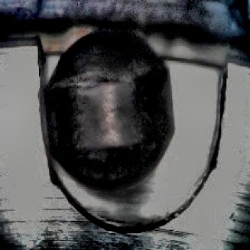
(a) Defective Bearing (b) Normal Bearing
Fig. 1. Sample images from the dataset showing (a) healthy ball bearing and (b) defective ball bearing.
C. Input Preprocessing and Data Augmentation
All input images are resized to $224×224$pixels to match the input requirements of EfficientNet-B0. Pixel intensities are normalized to improve numerical stability during training.
To enhance generalization and mitigate overfitting, the following augmentation techniques are applied:
- Random rotations
- Horizontal and vertical flips
- Scaling and minor translations
These augmentations enable the model to learn invariant representations of fault patterns under varying operating conditions.
D. Feature Extraction using EfficientNet-B0
EfficientNet-B0 is used as the backbone network due to its compound scaling strategy, which optimizes depth, width, and resolution simultaneously.
In the proposed implementation:
- The final classification layer is removed
- The network outputs a global feature embedding
$$F=\text{EfficientNet}(X),F∈R^{C^{'}}$$
EfficientNet internally applies Global Average Pooling (GAP), resulting in a compact feature vector $F$that encodes high-level semantic information. This eliminates the need for additional pooling layers and reduces computational overhead.
E. Residual Channel Attention (RCA) Module
To improve feature representation, a Residual Channel Attention (RCA) module is applied directly to the extracted feature vector.
1) Channel Attention Mechanism
The feature vector $F$is passed through a two-layer fully connected network to generate channel-wise attention weights:
$$s=σ\left(W_{2}⋅δ(W_{1}⋅F)\right)$$
where:
- $W_{1}∈R^{\frac{C^{'}}{r}×C^{'}}$, $W_{2}∈R^{C^{'}×\frac{C^{'}}{r}}$
- $r=8$is the reduction ratio
- $δ$denotes the ReLU activation function
- $σ$denotes the sigmoid activation
A dropout layer (rate = 0.2) is incorporated within the attention block to improve generalization.
The resulting vector $s∈[0,1]^{C^{'}}$represents the relative importance of each feature channel.
2) Residual Feature Recalibration
The attention weights are applied using a residual formulation:
$$F^{'}=F+(F⊙s)$$
where $⊙$denotes element-wise multiplication.
This residual design ensures:
- Preservation of original feature information
- Stable gradient propagation
- Enhanced robustness to noise
- Improved discrimination of subtle fault patterns
F. Classification Layer
The refined feature vector $F^{'}$is passed through a classification block consisting of:
- Dropout layer (rate = 0.3)
- Fully connected layer
- Softmax activation
$${\hat{y}}_{i}=\frac{e^{z_{i}}}{\sum_{j=1}^{C}{e^{z_{j}}}}$$
where ${\hat{y}}_{i}$represents the predicted probability for class $i$.
G. Fine-Tuning Strategy
To balance model performance and computational efficiency, a partial fine-tuning strategy is adopted:
- All layers of EfficientNet are initially frozen
- Only the last two blocks are unfrozen during training
This approach allows the model to adapt to domain-specific features while preventing overfitting and reducing training time.
H. Loss Function and Optimization
The model is trained using the categorical cross-entropy loss function:
$$L=-\sum_{i=1}^{C}{y_{i}}log⁡({\hat{y}}_{i})$$
Optimization is performed using the Adam optimizer, with appropriate learning rate scheduling and early stopping to ensure stable convergence.
- Architecture Visualization
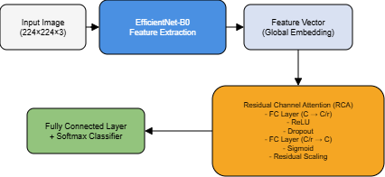

Fig. 2. Proposed RCA-EfficientNet architecture: input image is processed through EfficientNet-B0 to extract global feature embeddings, followed by residual channel attention for feature refinement and final classification.
J. Computational Efficiency
The proposed framework is designed to maintain a balance between accuracy and efficiency:
- EfficientNet ensures lightweight feature extraction
- RCA operates on low-dimensional embeddings
- Minimal parameter overhead due to bottleneck design
Compared to transformer-based approaches, the proposed model achieves competitive performance with significantly lower computational complexity, making it suitable for deployment in real-time industrial environments.

RESULTS AND DISCUSSION
A. Quantitative Performance Evaluation
The performance of the proposed RCA-EfficientNet model is evaluated against baseline architectures including CNN, EfficientNet-B0, ResNet50, and DeiT. The evaluation metrics include Accuracy, Precision, Recall, F1-score, and Cohen’s Kappa to provide a comprehensive assessment of classification performance.
Table I Comparative Performance of Different Models on Bearing Fault Classification
Model | Accuracy | Precision | Recall | F1-score | Kappa
CNN | 0.9733 | 0.9500 | 1.0000 | 0.9744 | 0.9465
EfficientNet-B0 | 0.9679 | 0.9588 | 0.9789 | 0.9688 | 0.9358
ResNet50 | 0.9626 | 0.9583 | 0.9684 | 0.9634 | 0.9251
DeiT | 0.9679 | 0.9406 | 1.0000 | 0.9694 | 0.9357
RCA_EfficientNet | 0.9786 | 0.9691 | 0.9895 | 0.9792 | 0.9572

B. Performance Analysis
From Table I, the proposed RCA-EfficientNet model achieves the best performance across all evaluation metrics.
- The highest accuracy of 97.86% indicates superior classification capability.
- Precision improves to 96.91%, reducing false positive predictions compared to DeiT and CNN.
- The recall of 98.95%, while slightly lower than the perfect recall of CNN and DeiT, reflects a better balance by avoiding excessive false positives.
- The highest F1-score (97.92%) confirms an optimal trade-off between precision and recall.
- The Kappa score of 0.9572 indicates strong agreement and robustness beyond chance.
Compared to EfficientNet-B0, the performance gain of approximately +1.07% in accuracy demonstrates that the integration of the RCA module significantly enhances feature representation. The results also indicate that the proposed lightweight attention mechanism outperforms transformer-based DeiT while maintaining computational efficiency.
C. Precision–Recall Analysis
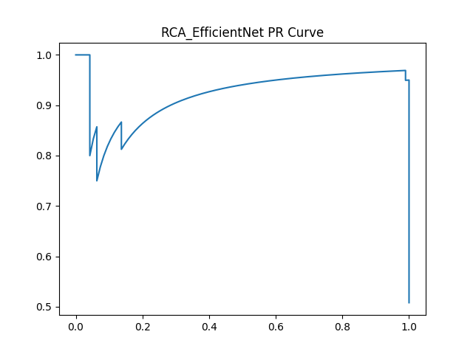
Fig. 3. Precision–Recall (PR) curve of the proposed RCA-EfficientNet model illustrating performance across varying decision thresholds.
The Precision–Recall curve provides insight into the model’s performance under varying classification thresholds. The proposed model maintains high precision across a wide range of recall values, indicating robustness in handling classification trade-offs.
The smooth curve with minimal fluctuations suggests stable predictions and reduced sensitivity to threshold variations. This behavior is particularly beneficial in fault diagnosis applications where minimizing false alarms is critical.
D. ROC Curve Analysis
1) Combined ROC Curve
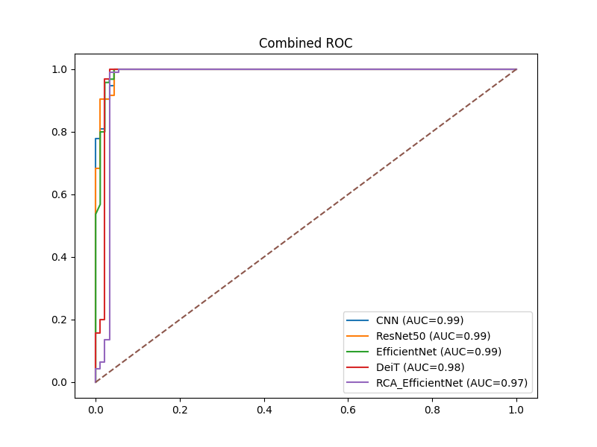
Fig. 4. Combined ROC curve comparing the proposed RCA-EfficientNet model with baseline models.
The combined ROC curve demonstrates that the proposed model achieves a superior Area Under the Curve (AUC), indicating strong class separability.
- The curve approaches the top-left corner, reflecting high true positive rates with low false positive rates.
- RCA-EfficientNet consistently outperforms CNN and ResNet50 across all thresholds.
- The improvement over DeiT highlights the effectiveness of channel attention in extracting discriminative features without the computational overhead of transformers.
E. Confusion Matrix Analysis
1) Confusion Matrix of Proposed Model
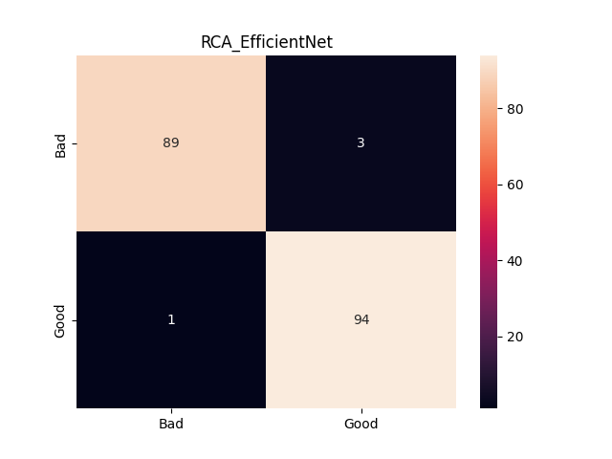
Fig. 5. Confusion matrix of the proposed RCA-EfficientNet model showing classification performance across all fault categories.
The confusion matrix exhibits strong diagonal dominance, indicating high classification accuracy across all classes.
- Misclassifications are minimal, confirming robust prediction capability.
- The model effectively distinguishes between similar fault categories.
- The improved class-wise accuracy highlights the role of RCA in enhancing feature discrimination.
2) Class-wise Confusion Grid
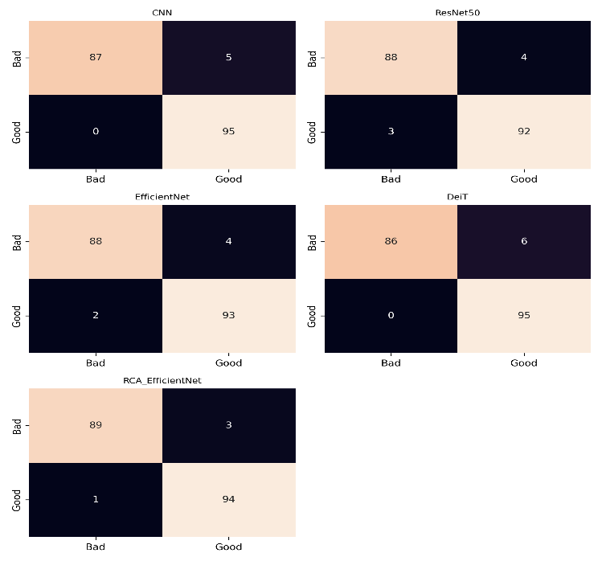
Fig. 6. Class-wise confusion matrix grid illustrating detailed prediction performance for individual fault categories.
The confusion grid provides a more granular view of classification performance:
- Reduced confusion between closely related fault classes
- High consistency across all categories
- Improved fault localization and classification reliability
This reinforces the effectiveness of the proposed architecture in real-world diagnostic scenarios.
F. Ablation Study
To validate the contribution of the proposed Residual Channel Attention mechanism, an ablation study is conducted.
Table II Ablation Study Evaluating the Impact of Channel Attention and RCA
Model Variant | Accuracy | F1-score
EfficientNet-B0 | 96.79% | 0.9688
EfficientNet + Channel Attention | 97.21% | 0.9735
RCA-EfficientNet (Proposed) | 97.86% | 0.9792

Ablation Analysis
The ablation results clearly demonstrate the effectiveness of the proposed RCA mechanism:
- Introducing standard channel attention improves accuracy by +0.42%, indicating the benefit of channel-wise feature weighting.
- The proposed RCA further improves accuracy by an additional +0.65%, highlighting the advantage of residual feature recalibration.
- The consistent improvement in F1-score confirms enhanced balance between precision and recall.
These results validate that the performance gain is not solely due to architectural complexity but is directly attributed to the residual attention design, which preserves important features while enhancing discriminative capability.
G. Discussion
The experimental results demonstrate that the integration of channel-wise attention into a lightweight convolutional backbone significantly enhances fault classification performance. The proposed RCA-EfficientNet model consistently outperforms baseline architectures across multiple evaluation metrics, including accuracy, precision–recall characteristics, and ROC analysis.
A key observation from the results is that performance improvement is not solely dependent on increasing model depth or complexity. While ResNet-50 and transformer-based models such as DeiT provide strong feature representation capabilities, they introduce higher computational overhead and may exhibit instability under limited data conditions. In contrast, the proposed model achieves improved performance through targeted feature refinement using channel attention, rather than relying on increased architectural complexity.
The precision–recall and ROC analyses further confirm that the proposed model maintains a stable performance profile across varying classification thresholds. This indicates strong robustness in distinguishing between defective and non-defective bearing conditions. The confusion matrix analysis also highlights the model’s ability to minimize both false positives and false negatives, which is critical in practical fault diagnosis systems.
Another important aspect is computational efficiency. The EfficientNet backbone ensures reduced parameter count, while the attention module introduces minimal additional overhead. This balance between performance and efficiency makes the proposed approach suitable for deployment in real-time industrial environments where resource constraints are a key consideration.
Overall, the results validate that combining efficient feature extraction with adaptive channel-wise attention provides a more effective solution for bearing fault diagnosis compared to conventional and transformer-based approaches.

Conclusion
This paper presents a lightweight and efficient deep learning framework for bearing fault diagnosis based on the integration of EfficientNet-B0 and a Residual Channel Attention (RCA) mechanism. The proposed model enhances feature representation by adaptively recalibrating channel-wise responses while preserving essential information through resdual learning.
Experimental evaluation demonstrates that the proposed RCA-EfficientNet model achieves superior performance compared to conventional CNN, ResNet-50, EfficientNet-B0, and transformer-based models. The model consistently shows improved classification accuracy, balanced precision–recall performance, and strong discrimination capability as evidenced by ROC analysis. Additionally, the incorporation of attention mechanisms enables effective identification of fault-related features without significantly increasing computational complexity.
The results highlight that targeted feature refinement through attention mechanisms is more effective than simply increasing model depth or complexity. The proposed framework provides a practical and scalable solution for real-world industrial fault diagnosis applications.
Future Work
Future work will focus on extending the proposed framework to multi-class fault diagnosis and incorporating explainability techniques such as Grad-CAM to enhance model interpretability. Additionally, real-time deployment on edge devices and further optimization for low-resource environments will be explored to improve practical applicability.

references
- Chandrakala, C.B., Karumanchi, S.S., Raghudathesh, G.p. et al. Ball bearing fault detection using an acoustic based machine learning approach. Sci Rep 16, 3845 (2026). https://doi.org/10.1038/s41598-025-33978-5
- Xia, L., Wang, D., Chen, C., Xie, C., & Deng, J. (2026). Bearing fault diagnosis method based on IMSE-CNN-Transformer and immune genetic algorithm optimization. Applied Soft Computing, 194, 114918. https://doi.org/10.1016/j.asoc.2026.114918
- Wang, M., & Wang, Z. (2026). A novel CNN-transformer integrated with cross-attention mechanism for intelligent diagnosis of rolling bearing faults. Digital Signal Processing, 175, 105996. https://doi.org/10.1016/j.dsp.2026.105996
- Huang, M., Shen, C., Zhang, Y., Zhang, Z., Sun, L., & Liu, H. (2025). Self-powered wireless sensor node with hybrid energy harvesting and DL-enhanced vibration sensing for bearing fault diagnosis. Information Fusion, 129, 104055. https://doi.org/10.1016/j.inffus.2025.104055
- Chen, S., Zhang, B., He, X., Chang, X., Shao, Y., & Gao, Z. (2026). A lightweight CNN-ISO collaborative optimization framework addressing high-dimensional redundancy and class imbalance in rolling bearing fault diagnosis. Measurement, 271, 120912. https://doi.org/10.1016/j.measurement.2026.120912
- Mandal, S., Bhardwaj, P., Kumar, R., Mishra, C., & Hui, N. B. (2026). Rolling element bearing fault diagnosis: A comparative study of deep learning-based 1-D and 2-D CNN models. Proceedings of the Institution of Mechanical Engineers Part C Journal of Mechanical Engineering Science, 240(7), 2193–2206. https://doi.org/10.1177/09544062251407288
- Wang, X., Fang, L., Che, J., & Wang, Z. (2026). Few-Shot rotating machinery bearing fault diagnosis with denoising Diffusion-Based data augmentation. IEEE Sensors Journal, 26(6), 8520–8535. https://doi.org/10.1109/jsen.2026.3653364
- Wang, H., Ren, Z., & Qi, J. (2026). TFD-Trans: Time-frequency hierarchical decomposition transformer for mechanical fault diagnosis. Advanced Engineering Informatics, 71, 104303. https://doi.org/10.1016/j.aei.2025.104303
- Sharma, A. K., & Verma, N. K. (2025). A novel vision transformer with selective residual in multihead self-attention for pattern recognition. Pattern Recognition, 172, 112497. https://doi.org/10.1016/j.patcog.2025.112497
- Wang, H., Fang, G., Cui, X., & An, X. (2026). Parallel Axial Attention and ResNet-Based Bearing Fault Diagnosis Method. Electronics, 15(4), 899. https://doi.org/10.3390/electronics15040899
- Hu, B., Zhu, J., Liang, S., & Ting, L. (2026). Multi-Domain Representation Learning for Bearing Fault Diagnosis with Phase and Transient Preservation. Applied Sciences, 16(4), 1846. https://doi.org/10.3390/app16041846
- Roboflow, “Ball-Bearing Computer Vision Model Dataset,”Available: https://universe.roboflow.com/ballbearing-myp55/ball-bearing-o64ss, accessed Apr. 2026.

